November 2017 All-Council Meeting
Exec and Committee Chair updates

Executive Officer Updates:
President (Tyler Allen)
- No updates

Vice-President of Internal Affairs (Doug Czajka)
- A reminder that we will be having elections for our new treasurer at the end of the meeting immediately following the closing of nominations; we have had four candidates nominated and accept. Please be sure to read the personal statements of the candidates as they are emailed to you (we should have them all by 5pm on Sunday 11/26), and come prepared with any questions you may have for the candidates. They will each have 3-4 minutes to speak, and then we will allow time for questions from the council floor. Voting will be done via paper ballot, and if no candidate receives a majority of votes, there will be a runoff between the top two vote getters. Only one representative from each department in good standing is eligible to vote. Below are the constitutional duties of the treasurer, which may help you evaluate the candidates.

E. The Treasurer shall:
1. Keep the financial records of the GSA.
2. Serve as a member and liaison, but not chair, of the Social Committee
3. Work with the Vice President of Internal Affairs and Secretary on the calculation and distribution of chapter rebates.
4. Coordinate the submission of annual budget requests from the GSA internal standing committee chairpersons. The budget requests may be submitted in a manner chosen by the Treasurer and approved by the GSA Council.
5. Submit the annual budget, approved by the Executive Board, to the GSA Council.
6. Oversee block grant requests in accordance with the GSA Block Grant Policy.

Vice-President of External Affairs (Nathan Corder)
- Federal Tax Legislation
  - As most of you will be aware, the Tax Cuts and Jobs Act that passed the House of Representatives earlier this month included language that threatens to raise taxes on graduate students. Specifically, section 1204 of the bill removes section 117(d) from the tax code that currently excludes tuition remuneration from taxable income. For graduate students, this would equate to an approximate $9K/$24K (resident/non-resident) increase in our taxable income. For instate students, this would result in hundreds more in taxes, and for non-residents, it would be thousands.
Over the past month I’ve been communicating with NAGPS as well as Duke and UNC to work out what our response should be. The Technician and The News & Observer also reached out for comment. I would also like to thank Judith Rivera and the Political Action and Special Projects Committee for helping disseminate information to reps and helping formulate a statement. Below is the information and outlooks as much as I know now. At the meeting I will discuss action items further:
- Currently, the Senate version of the tax plan does not have this language, so even if a tax bill passes the Senate, this language will have to be discussed in the conference committee. So far six Senate republicans have come out saying they are opposed or leaning opposed on the current senate version of the bill (two were hard no’s). Furthermore, Chairman Brady (House Ways and Means) was caught on mic saying he was not tied to the 117(d) removal. As such, the outlook that our tuition waivers will continue to not be counted as income looks favorable.
- In response to that weakening of resolve, NAGPS wants us to push the Senate to not introduce similar language and to pressure House representatives that could possibly be on any conference committee to relax on the language.
- There will be a general National Call-to-Congress day on November 29th
- NAGPS is asking universities in North Carolina specifically to follow up on December 6. Since Representative Holding is on House Ways and Means, they think it is likely he will be on that conference committee.

- Meeting with State Senator Jay Chaudhuri
  - On November 7, I attended a campus listening session put on by State Senator Chaudhuri. During open question time, I floated questions pertaining to two GSA initiatives that intersect with the state legislature. These topics were reworking residency definitions to count any student qualifying for GSSP as In-State for tuition purposes and the standardization of graduate health care coverage between UNC system schools.
  - The senator was not familiar with topics but expressed interest in learning more. He’s asked I put together briefs on both of the topics. I have a meeting scheduled with him December 8.

- Board of Trustees Meeting
  - At the invitation of student body president Jackie Gonzalez, I attended the Buildings and Property and the University Affairs subcommittee meetings of the Board of Trustees. As just a community member, I was not able to contribute to these meetings; however, I do believe continuing to have a graduate student presence at these meetings will be helpful if we intend to get a recognized seat on the committees. There was little of substance gained at these meetings that could not be found in the public releases.
- Standing Committee Updates
  - I received updates from the following committees:
    - Libraries
      - Administrators are looking into developing a project that would investigate the relationships and trends between the status (faculty, graduate student, undergraduate student) of a journal user, the number of downloads they make, and the types of journals they use. All information will be anonymized at the individual level (they’re only concerned about status and college/department affiliation).
      - Special Collections staff gave an overview of the Wolf Tales program, an effort to collect oral history interviews from groups on campus that are under- represented in the existing holdings of Special Collections. They’ve conducted approximately 100 interviews thus far, a majority of which are available in digital form online for researcher use. Staff is in the process of establishing ongoing partnerships with campus
    - Student Health
      - The Standing Committee on Student Health has determined that its role is now not unique from the Committee on Wellness and believes it should dissolve. This month’s meeting consisted primarily of the chair making that determination. No vote was taken.
      - I believe this will still need to go through the committee on committees in order to be formally dissolved, but we will be losing multiple seats on the committee if it goes through.
  - I worked with an outgoing rep serving on the Bookstore committee to help the transition of her replacement. We will not have any lapse in representation on the Bookstore committee.

Vice-President of Academic Affairs (Desiree Unselt)
- Three Minute Thesis was a success! Winners were Paul Enriquez (First Place), Tyler Allen (Second Place), and Ashish Kapoor (People’s Choice).
- The Graduate School is working towards developing a scholarship and fellowship assistance program. They are hoping to hire someone who will be able to find scholarships and fellowships that will meet the needs of graduate students. Additionally, this person will help with the application, interview, and disbursement processes. More developments to come!
- Research Ethics: The Graduate School Admin Board would like to find a way to standardize and further develop research ethics professional development to all graduate students. Currently, there is a wide variety of exposure required depending on the program/department as well as funding situation (NIH and NSF Fellowships).
- NCSU Graduate Student Research Symposium
  - March 21, 2018, 1pm-5:30pm, McKimmon Center
  - Free to attend! Free parking!
  - Always can use more judges, must be experts in their field. Can be in academia or industry. Please send contact info to VP of Academic Affairs.
  - Flyer to send to GSAs to come!

Vice-President of Communication (Ben Dictus)
- No updates.

Vice-President of Student Government Relations (Meredith Spence Beaulieu)
- Working on digitizing and organizing old GSA records. There’s a ton of them, so this will probably be a lengthy process, but well worth it!
- Still working on campus child care for grads, in collaboration with the Council on the Status of Women (CSW) and potentially the Women’s Center. HR’s Director of Employee Benefits has confirmed that they are currently doing a high-level overview of child care needs and possibilities, and plan to engage both GSA and CSW soon. I’ll be sending a follow-up email if I haven’t heard from HR again by the end of this week.
- Meeting with CSLEPS this Thursday regarding Leader of the Pack and other awards/opportunities not accessible to grad students, as mentioned in last month’s updates.
- Student Involvement (the entity that oversees all student orgs on campus, including GSA) is currently hiring a new director, and the hiring committee has invited student leaders to participate in the interview process by attending trainings put on by the candidates and then submitting their feedback. I attended one of these trainings last week and will be attending the other two trainings this week so that GSA is represented during this hire.
- I am always in need of people willing to serve as proxies when current grad Senators need to miss a meeting! Either I or Nick (chair of GRC) will be sending around a proxy interest form so that we can have a bank of potential volunteers when the need arises. Look for that soon, and please feel free to pass that along to your programs/departments to help widen the net.
- Graduate Delegation (i.e. your grad Senators) working on changes to the Campus Safety Escort Services. They are advocating for the program to serve some proximal locations beyond campus, as most grad students live off campus and so cannot benefit from the current services.
- As mentioned in the last meeting by Student Chief Justice Jess Errico, she is looking for grad students to essentially be on retainer as Conduct Board members for when grad students are going through the judicial process on campus. I forgot to include it in the first ICYMI SG email, so it will be in my next one. However, in the meantime, if you’re interested or know someone who might be, you can contact Jess at student-chief-justice@ncsu.edu.
- Upcoming SG events:
  - Accessibility Town Hall - February 7th at 4pm, location TBD
- Office hours are a little sparse due to the holidays and the winter break coming up, but please email me (gsa-vprelations@ncsu.edu) if you’d like to meet. I’ll be in the office (Talley 5261D in the UAB Suite) for my regular office hours Wednesdays from 4:30 to 5:30pm until December 13th, and then again starting January 10th.

Treasurer (Freddy Scholcover)
- We have spent $4800 this month (most of this went towards the fall travel award)

Secretary (Rachel Atkins: gsa-secretary@ncsu.edu)
- 80% of respondents (10 total) to the poll said they preferred updates through this document, so we will continue to do it! Hopefully you’re reading this before the all-council meeting...if you still have opinions about this that you want heard, feel free to respond to the poll here.
- If you are sending an email to the reps, please be sure to clearly indicate at the top of the message if it is for reps only or if you’d like them to forward to constituents. Reps - remember that you are the liaison between the GSA and your department/program so please be sure to forward information to them!

Internal Committee Updates:
Community Service (Ariel Rambaran: chair-csc-gsa@ncsu.edu, aerambar@ncsu.edu)
- There will be a box at the November All-Council meeting to collect items for Operation Christmas Child. We are collecting small toys, school supplies, and hygiene products to send to the Operation Christmas Child processing center for items to be packaged, and sent overseas to children who wouldn’t receive anything for Christmas otherwise.
Items must be able to to fit in a shoe box and items should be unwrapped
- Collection box locations for Operation Christmas Child:
- Engineer Building 2
- Caldwell Hall
- DH Hill library
- GSA Suite in Talley
Please pass this information to your departments.

Graduate Representation (Nick Faulkner: chair-grc-gsa@ncsu.edu)
- Spreadsheet update. Please be sure to fill out our spreadsheet online in order for us to know which departments are represented and which need to be reached out to. You should be receiving another email during this meeting, so please take another look! How many graduate students are not represented?
- The New GSA Startup Application Will be released in January. The deadline for this application will be March 15th. If you know any departments trying to start or join a GSA, let them know about this opportunity and please have them email me!
- We are always in need of Student Government proxies and will be looking for new senators come next semester. If you know anyone who would be willing to be “on deck” in case one of our current senators cannot make a meeting, please have them email me so that they can be put on a mailing list. Also, be looking for a google form to be distributed to your departments to assist in this!
- Because our original “Rep Packet” and other onboarding information is a little older, we have begun the process of creating a “New GSA Interest Packet” to aid in recruiting un-represented departments to our ranks.

Special Projects and Political Action (Judith N. Rivera: chair-spc-gsa@ncsu.edu)
- November 8th Call To Action: Thanks to everyone for sending out the last-minute November Call to Action! We had some good feedback and appreciate everyone involved.
- December 6th Call to Action: Keep an eye out for the December CTA which should be released to you all in about a week- please help us by distributing it as widely as possible as soon as it arrives in your inbox.
- Potential Call Bank Event to encourage calls and tweets to our congressmen (to coincide with Dec. 6th CTA). Details to be determined.
- We have been working on releasing a Joint-Statement between the GSA and Student Government regarding the H.R.1 Tax Cuts and Jobs Act that was recently passed in the House and currently up for debate in the Senate. We will have a copy of the statement ready for you all to view and vote on at the Nov. 27th All Council meeting.
  - View the latest version of the Joint-Statement HERE.
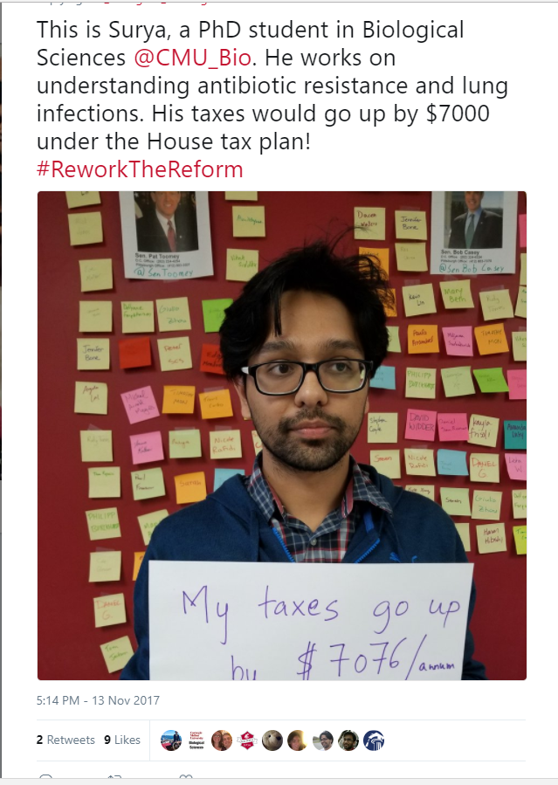
- Join the National Photo Campaign! We are working on a photo campaign, introduced by NAGPS, that includes pictures of grad students holding a message that reflects how the proposed Tax Cuts and Jobs Act will affect them. We will be on hand with a camera to take photos of you 15 minutes before the meeting, during the stretch break, and for a short time after the meeting. This is on a volunteer basis- feel free to arrive with a statement ready. We will also have pre-made statements on hand as well, if you prefer.
  - Photo Campaign: EXAMPLE
    - Describe your research in one-line
    - Hold the placard and state how tax will affect you
    - Share on social media (include #ReworkTheReform)
- Graduate Concerns Survey: We will be releasing a short-form copy of the survey within the next two weeks. Please, keep an eye out for this and be ready to distribute a copy to your constituents when the time comes.
- Constitutional Review Subcommittee: It’s not too late to join! If you are interested in joining please reach out ASAP. The first meeting will be on Tuesday Nov. 28th at 1:30pm in the Student Government Conference Room (Talley 4251D). Everyone is welcome to attend.
- Additional Information that we are forwarding on behalf of NAGPS regarding the Tax Cuts and Jobs Act:
  - November 29th National Call to Action video: https://youtu.be/-o0MDJc0kM4
  - Sign the National Petition from NAGPS: Petition
  - Sign the State-Wide Petition: Graduate School Community of NC Against the Taxation of Tuition Waivers in H.R. 1 - The Tax Cuts and Jobs Act
- As always, if you’re interested in additional info about any of this or just want to help our committee out, please feel free to reach out to myself or anyone else on the committee.

Professional and Organizational Development (Noah “Drew” Baker: chair-podc-gsa@ncsu.edu)
- Survey Recap - Thank you to everyone who filled out our climate survey! Your feedback was appreciated and helpful for our planning of future events
- Future Collaborations - PODC is collaborating with Triangle ComSciCon, a convention that seeks to help STEM majors explain their research to those outside the field, by securing them a space in Witherspoon on March 24th. We are also working to collaborate with the Career Development Center for a career fair “bootcamp” event in mid-February, more details to come.
- Best Practices Award - The PODC committee has completed its review and amendments of the Best Practices award and is ready for distribution. The deadline for the application is January 29th at 11:59 PM. Be on the lookout for an email with the application link soon.

Publicity (Alex Bailey: chair-publicity-gsa@ncsu.edu)
- The deadline for submitting graduate relevant news for the November PawPrints is TONIGHT at midnight. Please use the google form to submit to the committee: https://docs.google.com/forms/d/1IlZ0bcNHKSD69I8Z5KC5CVD2F580-nqdht-xAefAtOw/edit
- Be on the lookout for our new social media campaign “Howling Highlight”. We are celebrating graduate students who lift up other grads and help foster our sense of community.

Research Recognition (Urmila Adhikari: chair-rrc-gsa@ncsu.edu)
- Thanks to the Graduate School, we have received more travel funding, awards called the GSA Travel Assistance Awards. They are $500 awards, with the opportunity to provide over 20 awards, in addition to the five, $1500 GSA Award for Conferences. There will be two separate applications. The $500 award application will be a modified version of the GSA Award for Conferences application. The evaluation process will be discussed further in the spring.

Social (Nicole Lindor: chair-social-gsa@ncsu.edu)
- Next event is Friday, December 8th from 8pm- close at Polar Ice House on Buck Jones Road. It is an open house style event and entrance fees and ice skates are free for NCSU Graduate Students. Please pass the word on to your departments!
- Formal planning is underway! Please let us know if you have feedback or suggestions for this year.

Teaching Effectiveness (Todd Wilson: chair-tec-gsa@ncsu.edu)
- The TA Soirée was a great success! We had nearly 70 people there. We look forward to next year!
- The first official meeting of the TA Awards Subcommittee is this Wednesday, November 29, at 5:00. Location: Talley Student Union room 4251D.

