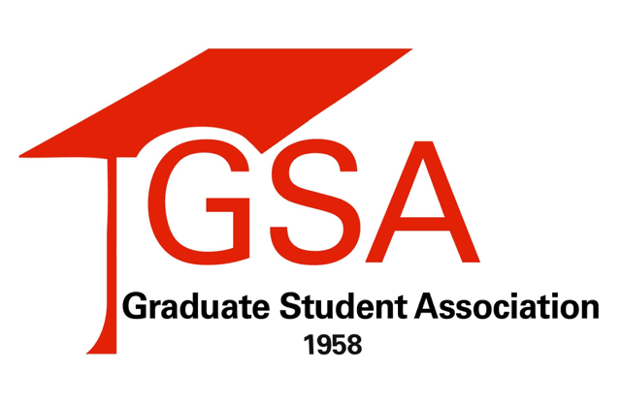
Wednesday, November 29, 2017

For Immediate Release
Organizations: NC State University Student Government & Graduate Student Association
Contact: Student Body President, Jackie Gonzalez, sbp@ncsu.edu
Graduate Student Association President, Tyler Allen, gsa-president@ncsu.edu

An Open Letter to United States Congress:
The Tax Cuts and Jobs Act

Dear Members of Congress:
On behalf of the Student Government and Graduate Student Association at NC State University, we write to express grave concerns regarding both the House and Senate versions of the “Tax Cuts and Jobs Act” bill (TCJA). On November 16th, the U.S. House of Representatives passed H.R.1 and the bill is now up for debate in the U.S. Senate. This bill amends the Internal Revenue Code to reduce tax rates and modify policies, credits, and deductions for individuals and businesses. However, there are many provisions within H.R.1 that, if implemented, will make achieving a quality college education significantly more expensive for students and their families and present a devastating, long-lasting impact on all institutions of higher education. Graduate students nationwide will be forced to spend a large portion of their already limited stipends on taxes and take on additional debt to afford graduate school. Furthermore, the provisions in H.R.1 will stymie the innovation necessary to maintain the globally competitive market of the Research Triangle by inhibiting our ability to attract the best and brightest to our NC institutions.
Specifically, our main objections to the House version of the TCJA include Section 1204’s elimination of the qualified tuition reduction, which would remove the tax-exempt status for tuition payment/waivers and result in thousands of NC graduate students being subjected to a significant tax increase, as well as Section 1201, a repeal of the Lifetime Learning Credit and Hope Scholarship while not substantially increasing the American Opportunity Tax Credit (AOTC). While we appreciate that Sec. 1201 expands the AOTC to include a 5th year, we are disappointed that it precludes part-time students, graduate students, as well as any non-traditional students from accessing this credit and results in their losing the tax benefits they rely on to help finance their education.
With respect to the Senate version of the TCJA, we appreciate that this legislation retains several of the benefits to students that the House version removes. However, our main objection to the Senate version of the bill includes the repeal of the deduction for personal exemptions, which completely eliminates a taxpayer’s ability to claim a deduction for dependents, including dependent children who are full-time college students. Eliminating this deduction would further decrease college affordability for families already struggling to keep up with rising tuition costs across the state and nationwide. In addition, and most critically, we strongly oppose the introduction of any language similar to that of H.R.1’s elimination of the qualified tuition reduction into the Senate version of the bill, as this removal of tax-exempt status for tuition waivers will adversely affect all graduate students and create a significant barrier to entry into graduate education.
Additional provisions found in either the House, Senate, or both versions of the TCJA that will negatively impact NC State students, faculty, and their families are listed below:
- Changes to the standardized deduction and decrease of the charitable deduction, which will reduce charitable contributions to our institution,
- Repeal of educational assistance programs, which would remove tax-exempt status of tuition assistance offered by employers.
- Repeal of the Student Loan Interest Deduction, which will increase the cost of student loans for borrowers, and
- Repeal of the state and local tax deduction, which will reduce funding for public higher education.
Beyond those listed above, there are still other provisions that we have not addressed that could negatively affect graduate students at private universities. For all of these reasons, we strongly oppose the H.R.1 Tax Cuts and Jobs Act as well as any other tax bill in the Senate that introduces changes to the tax code similar in nature to all those we have mentioned. We urge that these problematic provisions be removed during reconciliation of the House and Senate plans.

Sincerely,

NC State University
Student Government & Graduate Student Association

Sources: H.R. 1 "Tax Cuts and Jobs Act"
National Association of Graduate and Professional Students
American Council on Education

